Chapter 4, Problem 63.

Find the Norton equivalent for the circuit in Fig. 4.129.

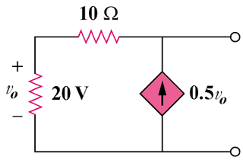

Figure 4.129
For Prob. 4.63.

